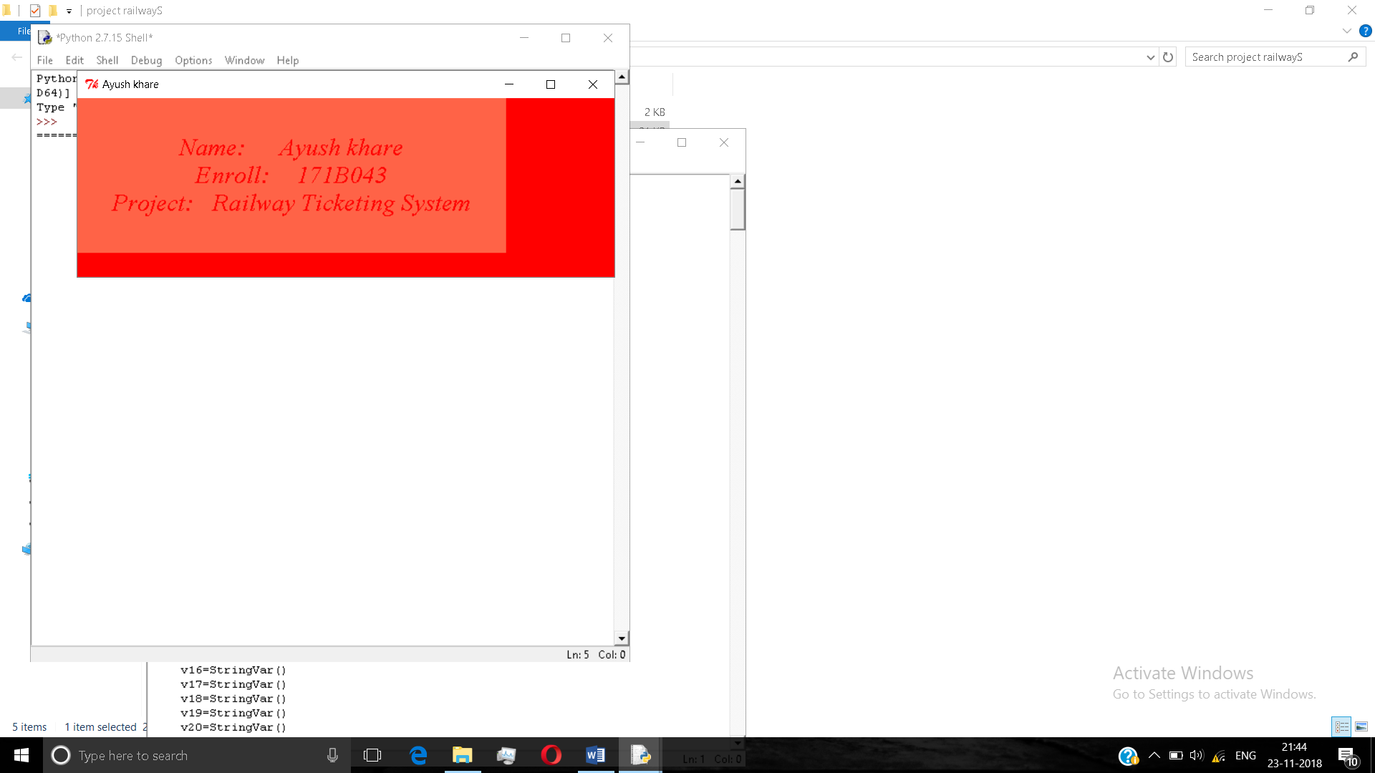

This is the splash window which pops after we run the program. This window shows the name ,enrolment and the project name of the student. And after we move cursor to this window the main project runs.

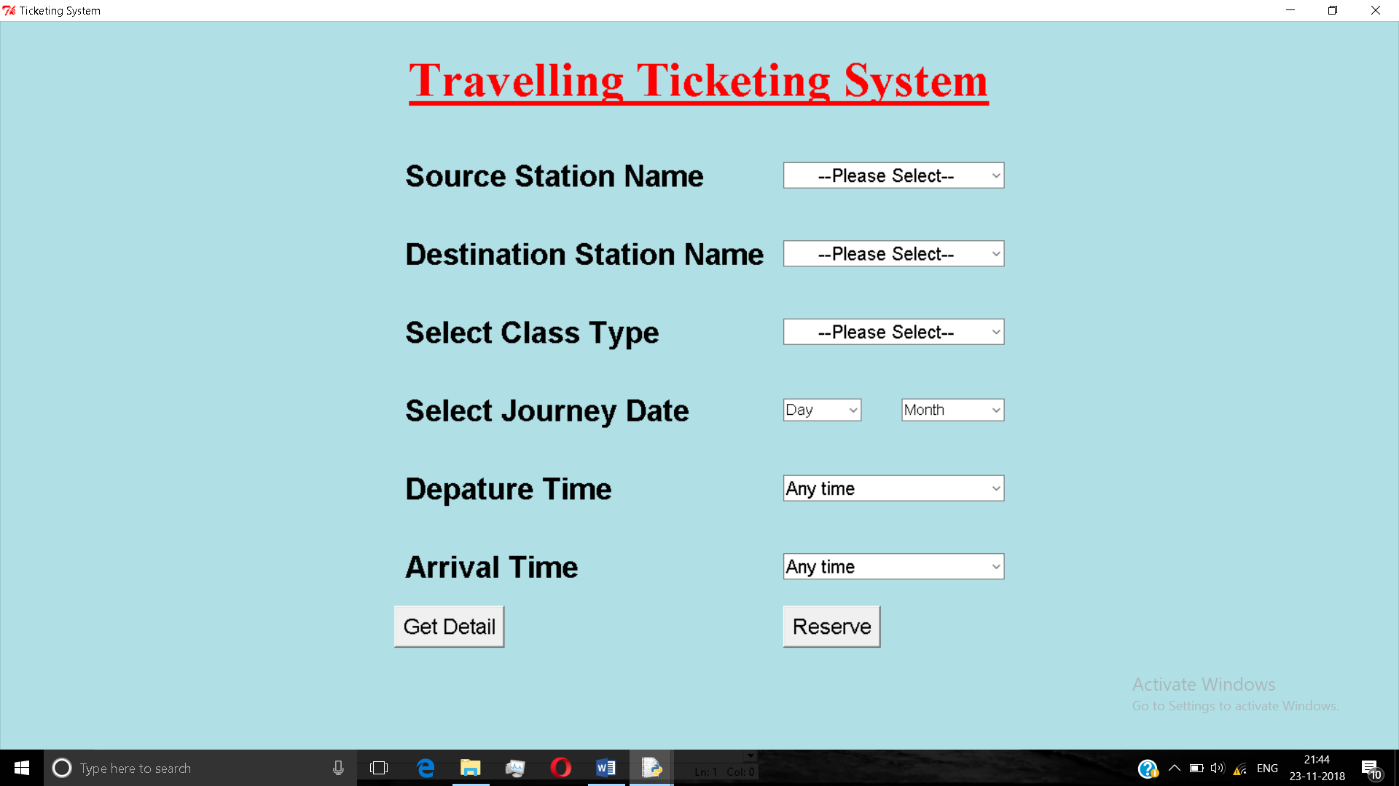

This is the main project starting window which shows the “Travelling Ticketing System” in which you need to select station name, destination name, class type, journey date, departure time and the arrival time filling all the entries press “reserve” key that will take you to the next screen.

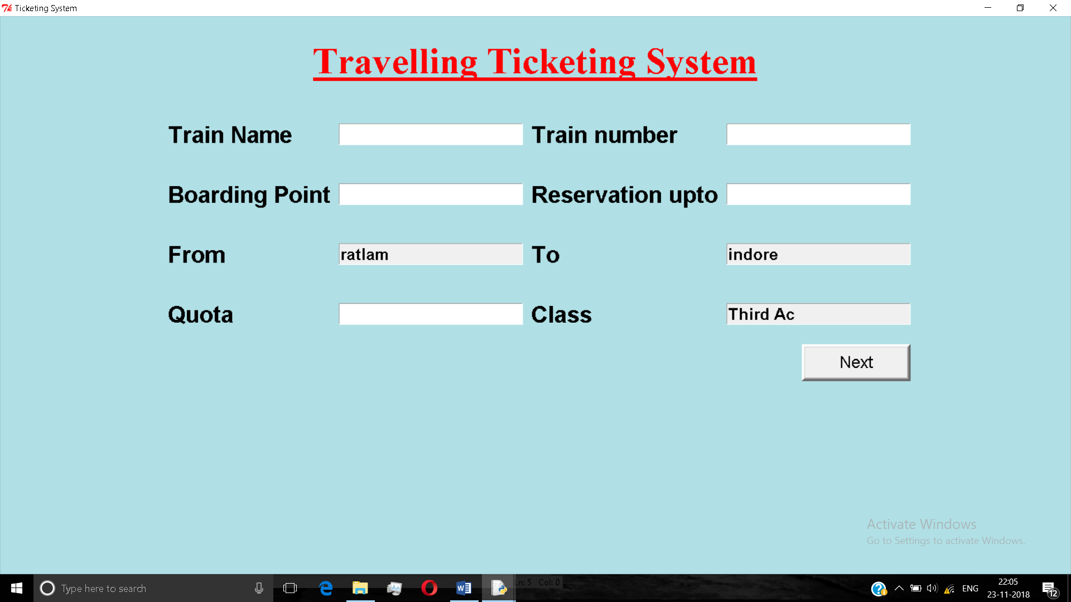

This window shows you the next options for booking a ticket. In this window we need to type the train name, train number, boarding point, reservation up to , quota that’s and after filling this columns click on next button which will take you to the next screen.

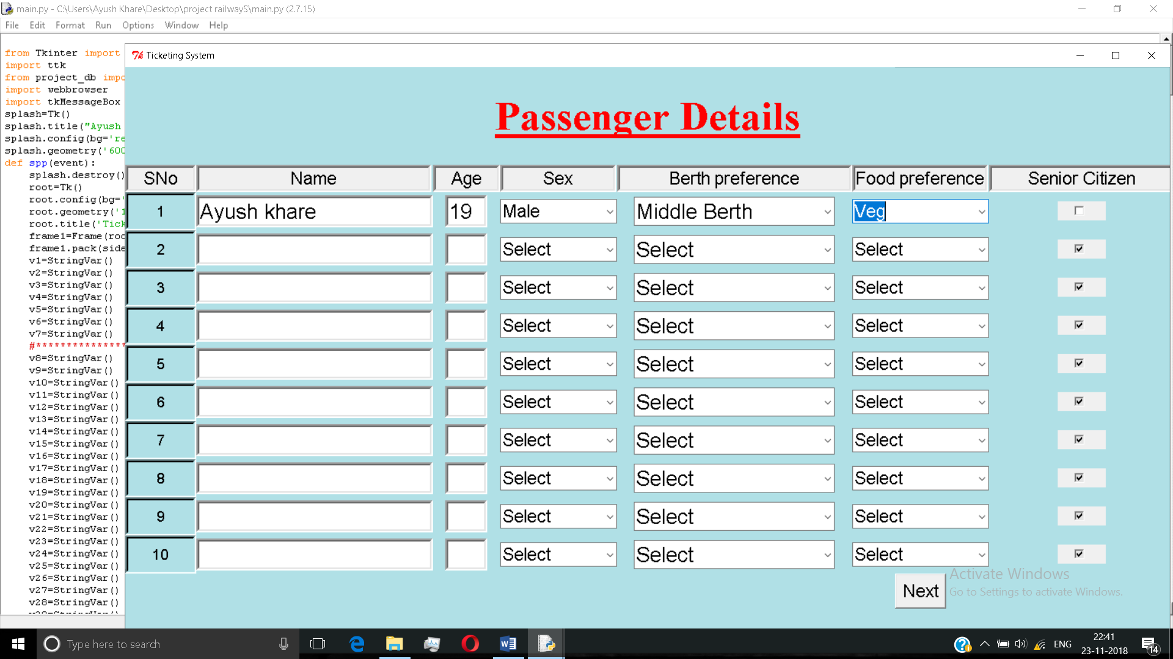

After clicking on NEXT this window will appear ,in this we need to fill all the entries of the passenger travelling his\her name ,age ,gender ,birth preference ,food preference and in this we can book tickets of up to 10 persons. And after this click on NEXT to go to the next window.

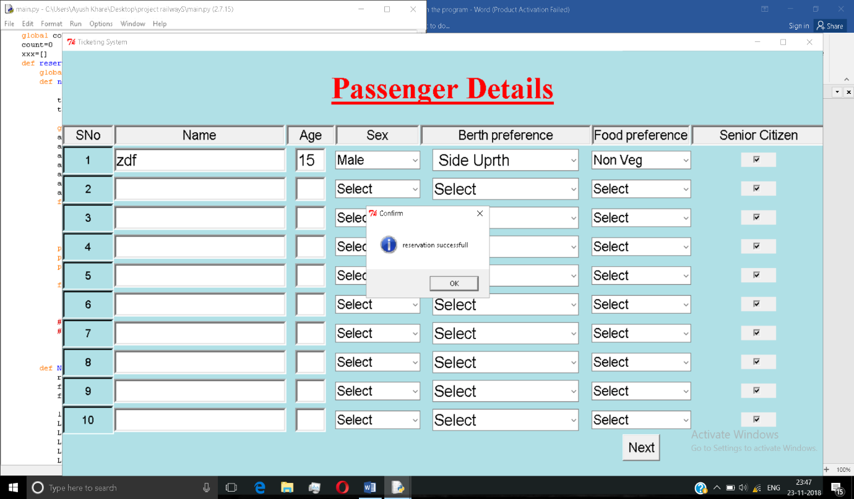

After pressing the NEXT button we will get the “reservation successful “popup window.